**BlueBell**

**Parul Institute of Computer Applications**

**Semester IV Project**

**2024-25**

**Ankit Singh Giri Siddharth Nishant Rohin**

**2305103140003. 2305103140013 2305103140019**

**Bluebell – Use the best , website to show how cryptography , encryption works .**

**INDEX**

* **Abstract**
* **Comparison of New System with Existing System**
* **Technology and HW, SW Requirement Specification**
* **Modules and its short description**
* **Users and their role description**
* **Limitations**
* **References & Bibliography**

Abstract

* + modern-day applications.""This project integrates cryptography, steganography, and QR code generation in a unified web interface to enhance data security and concealment. It provides a seamless solution for encrypting data, hiding it within media files, and encoding it as QR codes for secure transmission.“
  + "By combining these technologies, the project offers a comprehensive approach to secure communication in

Comparison of new system with existing system

* **Existing Systems:**
* Cryptography and steganography are often implemented separately.
* Existing systems might lack user-friendly interfaces.
* QR code applications are primarily focused on data sharing, not security.
* **New System:**
* Combines all three techniques in one platform.
* Enhances usability and efficiency.
* Provides multilayered security: encryption (data protection), steganography
* (concealment), and QR codes (sharing medium).
* **Benefits:**
* Higher security.
* Simplified workflow.
* Broader applicability for secure messaging, file sharing, and data storage.

Technology and HW, SW Requirement Specification

* **Technologies Used:**
* **Frontend:** HTML, CSS, JavaScript.
* **Backend:** Python/Node.js (mention specific frameworks like Flask/Django if used).
* **QR Code Library:** pyton
* **Hardware Requirements:**
* Minimum: Core i3 processor, 4GB RAM.
* Recommended: Core i5 or higher, 8GB RAM, 500GB storage.
* **Software Requirements:**
* Web browser (Google Chrome/Firefox).
* Operating system: Windows, macOS, or Linux.
* Python/Node.js runtime environment.
* Any IDE (Visual Studio Code, PyCharm).

Modules and its short description

* **Module 1: Cryptography**
* Encrypts user data using algorithms like AES or RSA.
* Ensures data confidentiality.
* **Module 2: Steganography**
* Hides encrypted data within image or audio files.
* Provides an additional layer of security.
* **Module 3: QR Code Generation**
* Converts the concealed/encrypted data into a scannable QR code.
* Facilitates secure data sharing.
* **Module 4: User Interface**
* Simple, intuitive web interface to integrate all functionalities.

Features and its short description

* **Data Hiding**: Conceals encrypted data within images or audio files.
* **QR Code Generation**: Converts encrypted data into scannable QR codes.
* **QR Code Decoding**: Retrieves and decrypts hidden data from QR codes.
* **Web-Based Interface**: User-friendly platform for seamless interaction.
* **File Upload**: Allows uploading files for embedding or extracting data.
* **Algorithm Options**: Supports multiple encryption methods.
* **Cross-Platform**: Accessible on any browser-enabled device.
* **Real-Time Preview**: Shows live QR code generation.
* **Secure Sharing**: Combines encryption, steganography, and QR for secure communication

for secure communication

* **Admin:**
* Oversees system functionality.
* Manages encryption algorithms and QR code configurations.
* **End Users:**
* Inputs data for encryption.
* Uploads files for steganography.
* Scans and decodes QR codes to retrieve data.

Limitations

* Limited to small file sizes for steganography

(e.g., low image resolution).

* Security depends on the strength of the cryptographic algorithm.
* QR codes might not support large datasets directly

(may require segmentation).

Future Enhancement

* **Support for Multiple Cryptographic Algorithms**
* Add support for algorithms like Elliptic Curve Cryptography (ECC)

or hybrid algorithms to offer flexibility and stronger security.

* **Steganography for Video and Audio Files**
* Extend steganography functionality to support embedding data

within video or audio files, increasing its use cases in multimedia security.

* **Dynamic QR Code Generation**
* Develop dynamic QR codes that update data in real-time, useful for scenarios

like live authentication or secure payments.

* **Mobile Application Integration**
* Create a companion mobile app for Android and iOS to scan and decode QR

codes directly, enhancing accessibility.

* **End-to-End Encryption with Blockchain**
* Integrate blockchain technology for decentralized storage and

validation of encrypted data.

References & Bibliography

* - **The Code Book: The Science of Secrecy from Ancient Egypt to Quantum Cryptography** – Simon Singh
* **Information Hiding: Techniques for Steganography and Digital Watermarking** – Stefan Katzenbeisser, Fabien A. P. Petitcolas
* **Modern Cryptography: Theory and Practice** – Wenbo Mao
* **Homomorphic Encryption and Applications** – Kristin Lauter, Nigel P. Smart
* **"Practical Cryptography in Python: Learning by Implementing"** – Seth James Nielson, Christopher K. Monson
* AI – chatgpt , deepseek , gemini
* www.google.com

SOME SCREENSHOTS OF THE PROJECT

(INCOMPLETE ).

Developers

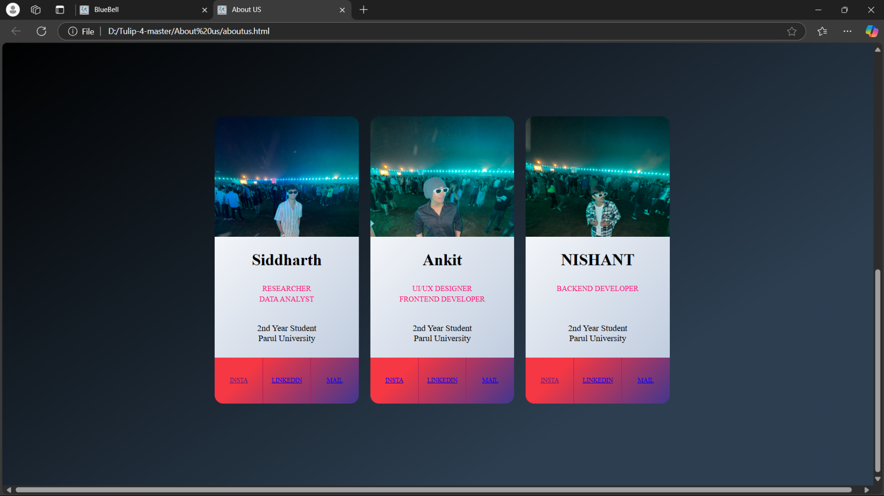

Main page

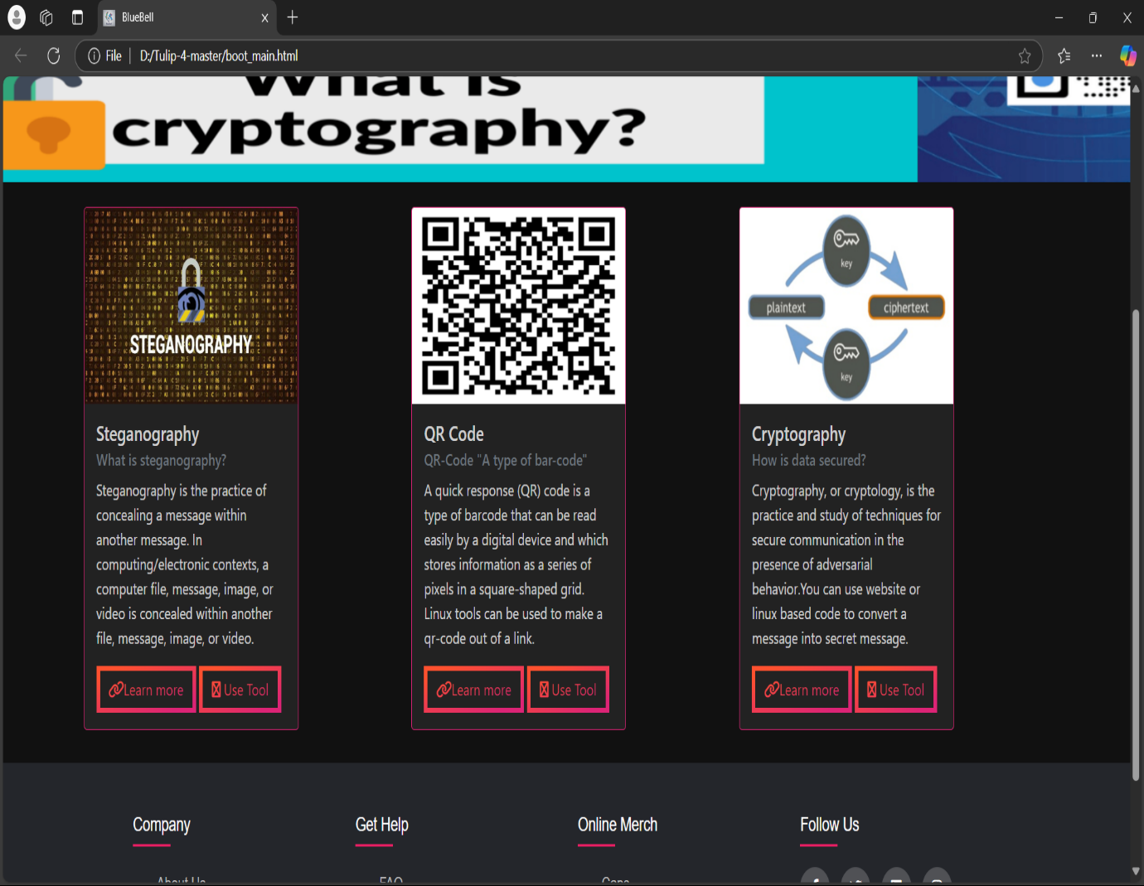

Description

about us 


Thank You..!!